NBA Player Projections Report

Ethan Michaels

I am using my predictive model to calculate the win share of each player based on 2022-23 statistics and using Seth Partnow's dollar value of each Win Share of 3.44 million dollars. I analyzed the players that exercised their player option, investigated resigning or releasing Clarkson and/or Olynyk’s contract, and lastly determining if any free agency signings should be useful for the Utah Jazz.

The graphic below shows the predictive model I used, it suggests that every player starts with a Win Share(WS) value of -4.15, and from here numerous Offensive and Defensive statistics affect their win share value. The variable that has the most significance is the True Shooting Percentage (TS.) which accounts for field goals, 3-point field goals, and free throws and the linear regression model represents that for every 1 percentage increase in True Shooting Percentage, a player win share increase 8.2 units. While a one-unit increase in points per game decreases a player's win share by 0.08. All variables below are described in per-game terms.

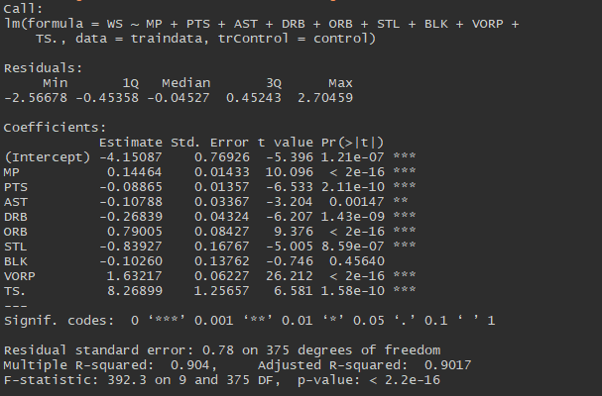

Upon analyzing the Utah Jazz Players that exercised their options we have Horton-Tucker (11mm), Gay (6.5m), and Jones (2.6mm). Looking first at Horton-Tucker, using the predictive model on 2022-23 statistics my model found his win share value to be set at 1.1 giving his evaluation of $4.02mm, Horton-Tucker takes up a good share of Minutes Per Game and contributes to the team while on the court but not in a great manner so unless his game improves dramatically it might be best for the Jazz to part ways with him. The same goes for Gay, my predictive model puts his win share value at 0.2 (a value of just $0.8mm), he doesn’t have great value to the team when he is on the court as much as he is. Jones on the other hand has a predictive win share of 3.15 (a $10.84mm valuation), for being a non-starter and his minimal time on the court he contributes nicely to the team and would look to give him another contract, given he has at least an average year.

Looking at players on the Jazz who we are looking to resign or cut we have Jordan Clarkson who wants to resign for a 4-year $80mm contract and Kelly Olynyk who is looking at a salary of $12.2mm a year. Clarkson played a key role for the Jazz in the 2022-23 season with having being the player with the 2nd most playing time, points per game, and assists per game. Clarkson contributed a fair amount given his playing time, my predictive model gave Clarkson a 3.07 win share total with a valuation of just $10.59mm. Comparing the valuation by the model and Clarkson’s offer of $19.9mm a year, I don’t think it would be in good interest to resign Clarkson unless he was looking to take a deal worth at most $15mm a year. For Kelly Olynyk the predictive model put a win share value of 4.55 valued at $15.6mm and his salary is expected $12.2mm this year. It's nice to see a player valued more than they are paid in terms of business, but the underlying question is how well he performs. Looking into it he was one of the best Jazz Players when it came to Rebounds, Steals, Blocks, Assists, and Points per game, all around Olynyk is a great player to have on the team, as a Center he brings a lot to the defensive side of the ball and is great at passing the ball and when needed can even score. I would recommend keeping Olynyk on the team.

After the analysis of Clarkson and Olynyk, I would recommend releasing Clarkson and signing Olynyk, giving the Utah Jazz $34.8 million in cap space for free agency which I will analyze now. Because we have a limited Cap Space and we are releasing Clarkson, I modified the free agency listing to give us all SG under $34mm cap space. From these modifications, we are given a list of 14 players that would fit this mold below:

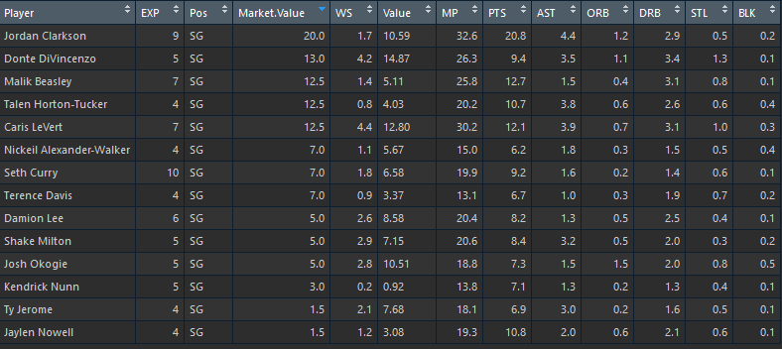

Overall, because we are releasing Clarkson, Horton-Tucker of the Jazz can take a year and increase his playing time and prove that he can keep growing as his career is still young. I think the best option would be to reinforce the position with a player who has more experience than Horton-Tucker to be more of a mentor as well as someone whose value can help the Jazz on the court. Keeping these things in mind I would look closer at Caris LeVert and Seth Curry to fill the SG role. Chris Levart although less experienced has greater value to the team, he has been on than Seth Curry as LeVart helps out on both sides of the ball and has numbers compared to Clarkson besides points per game. If we went out and Signed Caris LeVert that would leave the Jazz with $22.3mm in Cap Space.

Going through the Utah Jazz Roster and Statistics, one position I want to try to add another player to is SF, Jazz doesn’t have any notable SF that has a lot of value to the team so adding a player could be quite beneficial. After looking at the SF in free agency Kelly Oubre Jr. popped out with some great stat lines of 32.3 minutes per game and 20.3 points per game would help on the lost time and points from dropping Clarkson. Oubre, from my predictive model, has a win share value of 1.7, with a value of $8.18mm. His cap hit would be $12.5mm, leaving the jazz with roughly $10mm left in cap space. Although Oubre’s predicted WS valuation is less than his market value, it would be worth signing a player like that to help on the offensive and defensive side of the ball and could quite easily make back the missing value.

After all is said and done, the Jazz should look at releasing Clarkson, saving $20mm in Cap Space, and return sign Kelly Oubre and Chris Levart for a total of $25mm a year. Those two players statistically play great on both sides of the ball and make up for more than what we may have gotten from Clarkson, and with two more people in the game, value can come from anywhere.